Happy Birthday!

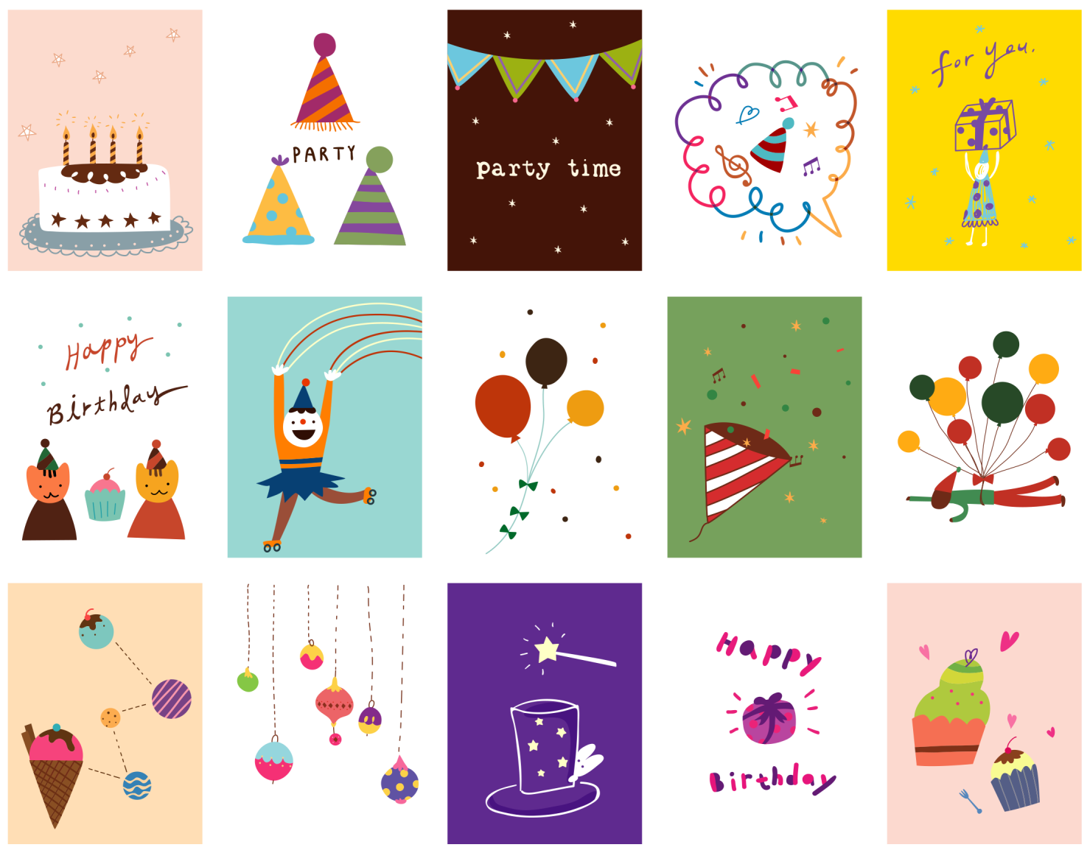

May your birthday be filled with sunshine

and smiles, laughter, love, and cheer.

From. Friend